Yasser Abd el Aziz, 4th level student (Helwan University) won with his team the third place at NYUAD Hackathon April 2015,Newyork University (Abu Dhabi Branch). More than 150 students participate at the hackathon from over 20 countries.

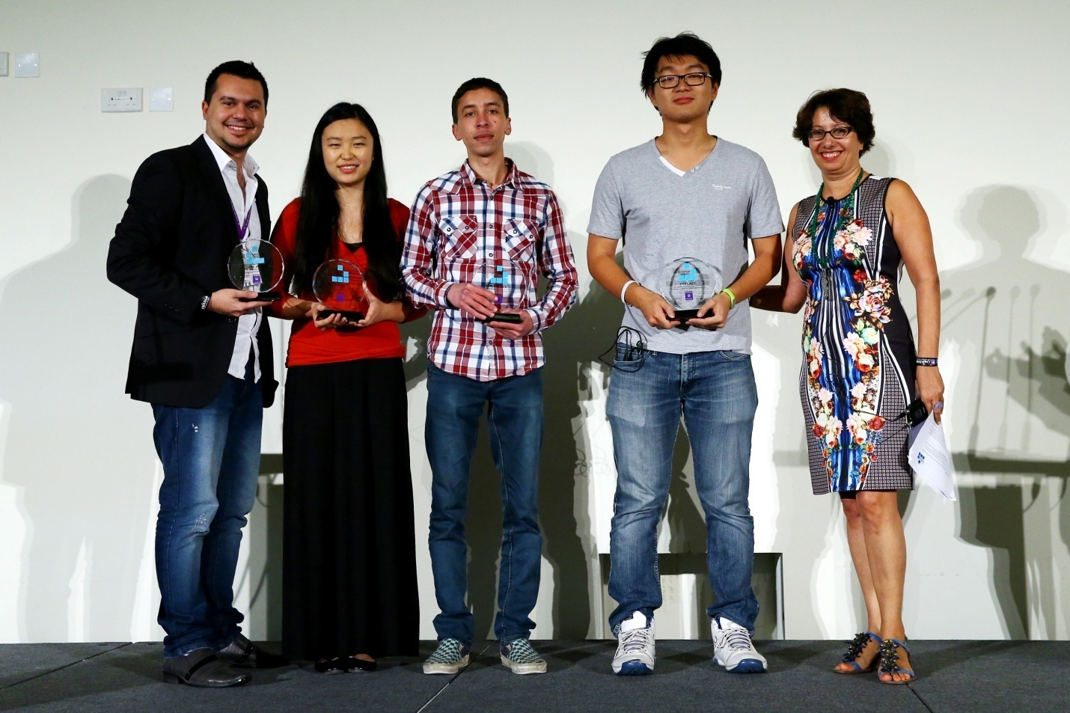
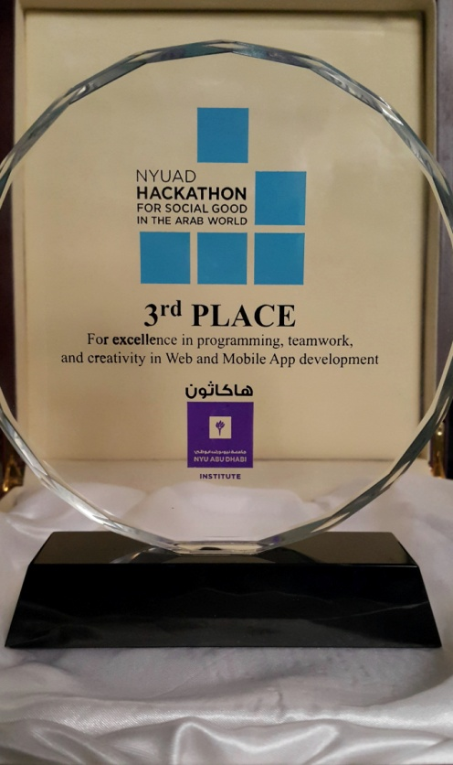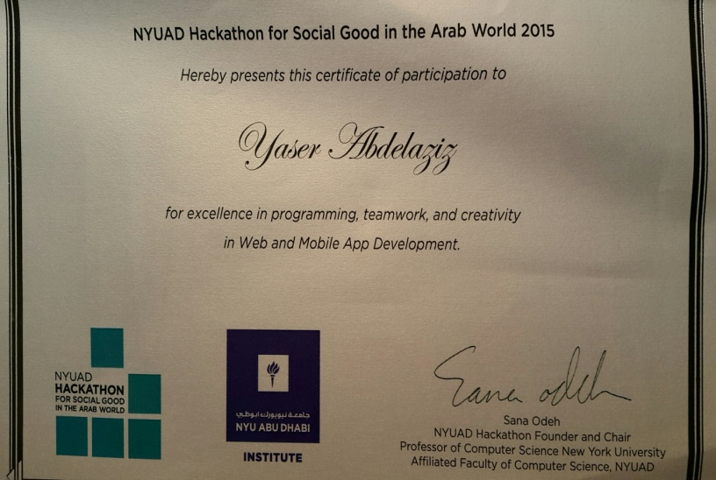

Four students have been nominated by Assoc. Prof. Mona Nasr and get the fully funded Scholarships to travel and participate at NewYork University (NYUAD) Hackathon 2013, 2014, 2015.

Year | Student Name | Level | Department
2013 | Saleh Ahmed  Hend Anwar | 4th Level  4th Level | CS  IS
2014 | Hesham Housam | 3rd Level | CS
2015 | Yasser Abd El Aziz | 4th Level | CS

